HAXBY TOWN COUNCIL |  | 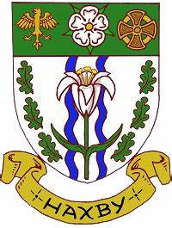
The Council Office, The Memorial Hall, Haxby, YO32 3HT
Telephone:  Email: | 01904 750378  clerk@haxbytowncouncil.gov.uk
HAXBY CARNIVAL – 13 JULY 2024 – STALL APPLICATION
The Carnival opens at 1.00pm on Ethel Ward Playing Field. Stall holders should set up between 10 am and 12 noon. Stall Holders should park their vehicles by 12 00pm. No cars will be allowed on the field before 4.30pm for safety reasons.

Name
Organisation
Email address
Telephone
Address

Activity
Stalls
Standard Pitch Size: 4m x 4m which will accommodate a standard 3m x 3m gazebo
There is an additional charge for tables.
Single Pitch £15
Double Pitch £25
Tables £5 each
TOTAL COST
I confirm that I have my own Public Liability Insurance

Please email this completed form to the Clerk, Alan Draper clerk@haxbytowncouncil.gov.uk
Payment by BACS: Barclays Bank Sort Code 20 99 56 Account Number 90455784 - include your name and Carnival Stall as reference.

TERMS AND CONDITIONS
- All stallholders must indemnify Haxby Town Council against all actions, proceedings, costs, claims and demands resulting from the operation of this agreement.
- Stallholders are responsible for their own health and safety and for the health and safety of those they employ and for the general public who access their stall.
- All equipment must comply with statutory standards.
- There will be no charge for charity stalls if their charity number is provided for the Clerk.

Closing Date for Stall Applications: Monday 1 July 2024

